**STATIONARY MANAGEMENT SYSTEM**

*Industrial Project report submitted*

*in partial fulfilment of the requirement for the degree*

*of*

**Bachelor of Technology** (Computer Science Engineering)

By

## SAHIL

**(Univ. Reg. No. 1913031026)**



DEPARTMENT OF COMPUTER SCIENCE ENGINEERING **HIMALAYAN INSTITUTES OF ENGINEERING & TECHNOLOGY KALA-AMB, SIRMAUR, (H.P.)**

*affiliated to*

## HIMACHAL PRADESH TECHNICAL UNIVERSITY HAMIRPUR, (H.P.)

### SEPTEMBER [2022]

# CERTIFICATE

It is certified that the work contained in the Industrial Training Report titled **“STATIONARY MANAGEMENT SYSTEM”** by **SAHIL** with University Roll No. **1913031026**, Department of **B.TECH (COMPUTER SCIENCE ENGINEERING)** has been carried out under my/our supervision and that this work has not been submitted elsewhere for a degree.

**Signature of Supervisor**

# CERTIFICATE BY COMPANY

Photocopy of certificate

# DECLARATION

I declare that this written submission represents my ideas in my own words and where other ideas or words have been included, I have adequately cited and referenced the original sources. I also declare that I have adhered to all principles of academic honesty and integrity and have not misrepresented or fabricated or falsified any idea/data/fact/source in my submission. I understand that any violation of the above will be cause for disciplinary action by the institutes and can also evoke penal action from the sources which have thus not been properly cited or from whom proper permission has not been taken when needed.

### Date:

**Signature of Student**

**SAHIL 1913031026**

# ACKNOWLEDGEMENT

I wish to express my profound gratitude to God Almighty and my parents for their support throughout my life.

I also wish to express my gratitude to my training In-Charge **Mr. VIKAS CHADHA (DIT MANAGER)** for providing me the opportunity to work with them and also for their support and encouragement throughout the process. The training was an extremely productive and enriching experience, not only technically but also from the viewpoint of providing practical skills.

I must place my gratitude towards **ER. CHETAN AGGARWAL (HEAD OF C.S.E. DEPARTMENT)**, **ER. RASHIM RANA (ASSISTANT PROFESSOR)** for their valuable advice and guidance in carrying out this enjoyable and productive experience, which provided me a great opportunity to search new horizons.

Finally, I would like to offer many thanks to all my colleagues for their valuable suggestions and constructive feedback. I would also thank my family who stood by me at all times and appreciated my work which inspired me to aim for the sky.

I am sincerely grateful to all.

## Signature of Student

**SAHIL 1913031026**

# COMPANY PROFILE



The **Department of Information Technology** was set up in 2004 with the mandate to lay a strong foundation for development of Information Technology (IT) in the state. The department strives to encourage investments in IT and IT Enables Services, facilitates the establishment of IT institutes, works for improving the quality of IT education in the state and is at the forefront in promoting usage of IT Tools for ensuring a SMART (Simple, Moral, Accountable, Responsive &Transparent) Government.

**DEPARTMENT FUNCTIONS:**

* Formulation and Implementation of the Information Technology Policy in the state.
* Introduction of automation and cybernation control systems so as to ensure faster information processing within Government, including projects and activities relating to e-Governance.
* Promotion of investment in Information Technology Sector (hardware, software and services-particularly ITES and BPO) and related activities and creation and upgradation of Information Technology infrastructure in the State.
* Assistance in development and implantation of software packages for monitoring of key parameters and computerization of thrust areas in different departments and semi- Government organizations
* Creation of Government-Public Interface through unified service delivery channel by using Information Technology and Information Technology enabled infrastructure and also to launch awareness campaigns on the advantages of the use of information Technology and related technologies in enhancing the standard of living and improving

quality of life.

* Standardization of hardware/software platforms for the departments/organization and to ensure dynamic monitoring of their prices and minimization of wasteful expenditure.
* Administrative control of Himachal Pradesh State Electronics Development Corporation.
* Formulation of strategy for a State-wide Internet.
* Development of information Technology related communication infrastructure.
* Assistance to the departments/semi Government organizations in creating and updating websites
* Promotion of Information Technology Education and training in educational institutions and government departments/semi-government organizations and facilitation of development/dissemination of educational software and promoting programs in Information Technology enabled education.
* Organization of various promotional activities like national/international conferences/seminars and participation in the same.
* Follow up of Information Technology related projects/schemes posed to the government of India and its agencies and also other players in this field in India as well as abroad.
* Facilitating the establishment of Venture Capital Fund by financial institutions for the growth of the Information Technology industry in the state.
* Identification of laws and rules which need to be modified or enacted to enable legal validation for the transaction and also to develop specific Cyber Coding for ensuring and maintaining secrecy and also to act as nodal agency/authority on behalf of the State Government for matters relating to Information Technology Act and similar other central and state legislation.
* Maintenance of database for all Information Technology related material and human resources available in the state.

# ABSTRACT

This is an **“STATIONARY MANAGEMENT SYSTEM”** project that serves the functionality of an admin, users and customers roles. The project allows all users, and customers. This project is developed in **JAVA**. User when click on **“PRODUCTS”** can check the products and update data.

The Stationery store provides all different types of books as well as all education related items. But there are lots of online shop as such but the sellers use various websites to sell their products. As the sites have n number of products, there isn’t a good response to from the costumers. In this we are providing you a virtual shop and user can explore whole stuffs on the tip of fingers without going to actual store and can pay when they received the package as well as we are providing exclusive feature where we putting offers on few items for a month and every month items will be updated.

# LIST OF CONTENT

|  |  |
| --- | --- |
| ***TITLE*** | ***PAGE NO.*** |
| *Certificate* | *I* |
| *Certificate by Company* | *Ii* |
| *Declaration* | *iii* |
| *Acknowledgement* | *iv* |
| *Company Profile* | *v-vi* |
| *Abstract* | *Vii* |
| *List of Contents* | *viii-ix* |
| *List of Tables* | *x* |
| *List of Figures* | *Xi* |

# LIST OF CONTENT

|  |  |  |
| --- | --- | --- |
| **Chapter:1** | **Introduction** | **1-2** |
| 1.1 | Introduction | 1 |
| 1.2 | Existing System | 1 |
| 1.3 | Proposed System | 1-2 |
| 1.4 | Objectives | 2 |
| **Chapter:2** | **Technology Used** | **3-11** |
| 2.1 | Methodology | 3 |
| 2.2 | JAVA | 4-5 |
| 2.3 | Hardware Specifications | 6 |
| 2.4 | Software Specifications | 6 |
| 2.5 | Feasibility Study | 6-8 |
| 2.6 | Fact finding Techniques | 9 |
| **Chapter:3** | **OUTPUT** | **12-21** |
| 3.1 | Output Snapshots | 12-21 |
| **Chapter:4** | **Conclusion** | **22** |
| 4.1 | Conclusion | 22 |
| 4.2 | Advantages | 22 |
| 4.3 | Limitations | 22 |
|  | **Appendix** | **23-24** |
|  | Appendix 1 | 23-24 |
|  | **References** | **25** |
|  | Book References | 25 |
|  | Website References | 25 |
|  | **Approval Sheet** | **26** |

# LIST OF TABLE

|  |  |  |
| --- | --- | --- |
| ***TABLE NO.*** | ***TITLE*** | ***PAGE NO.*** |
| 2.1 | Hardware Specification | 6 |
| 2.2 | Software Specification | 6 |
| 2.3 | Product Table | 10-11 |

**LIST OF FIGURES**

|  |  |  |
| --- | --- | --- |
| ***FIGURE NO.*** | ***TITLE*** | ***PAGE NO.*** |
| 2.1 | Features of Java | 5 |
| 3.1 | Home Page | 12 |
| 3.2 | Product | 12 |
| 3.3 | Pen | 13 |
| 3.4 | Gel Pen | 13 |
| 3.5 | Ball Pen | 14 |
| 3.6 | Pencil | 14 |
| 3.7 | Eraser | 15 |
| 3.8 | Sharpener | 15 |
| 3.9 | Scale | 16 |
| 3.10 | Protector | 16 |
| 3.11 | Compass | 17 |
| 3.12 | Divider | 17 |
| 3.13 | Notebooks | 18 |
| 3.14 | Books | 18 |
| 3.15 | Order | 19 |
| 3.16 | Order Confirm | 19 |
| 3.17 | Bill | 20 |
| 3.18 | Bill Print | 20 |
| 3.19 | Receipt | 20 |

# CHAPTER-1 INTRODUCTION

## Introduction:

Every educational institutes needs stationery products to carry out the day-to-day activities which involves the use of various stationery products such as registers, files, pens, printing papers, erasers, pencils, markers and many other things. Educational institutes Stationery Management System provides an application software to carry out activities regarding stationery products for the educational institutes which is an automated system instead of making manual entries into books which consumes a great amount of time. This project intends to introduce the user friendly application software for various related activities such as purchase order from staff members, stationery product requisition to suppliers, generate purchase orders for suppliers and generate bills for accounts section and many other related processes. Stationery is a mass noun referring to commercially manufactured writing materials, including cut paper, envelopes, writing implements, continuous form paper, and other office and school supplies. Stationery includes materials to be written on by hand (e.g., pen, pencil, notebooks, geometry sets, paper sheets) or by equipment such as computer printers. Stationary Store Management is a software application that is designed for the stores that deals in stationeries and other such shops. Here if we talk about getting it online we have a system which can maintain the whole objects of stationary in very classified manner and make it easy to take out the products fast.

## Existing System:

However, most of the educational institutes maintain a register for recording the transactions related to the stationery products purchased for the educational institutes. Very few educational institutes use an automated system software to carry out stationery products related activities. This existing system has several disadvantages. It requires lots of time. It is having lots of manual work. Since everyone is leading busy life now a day, time means a lot to everyone.

## Proposed System:

The aim of proposed system is to develop a system of improved facilities which has simple design and implementation. The proposed system, is very efficient and effective from the point

of view of work productivity and time. This system provides a software application to carry out the tasks related to stationery department of the educational institutes.

### Few of the properties are here:

* + 1. Better user interface.
    2. Less system resources required for operating.
    3. Better Optimization.
    4. Animation and transition.
    5. User-friendly and interactive designs.
    6. This application helps to generate bills for accounts section etc.
    7. This application provides an easy user interface which helps the users to learn the usage of the application easily and quickly.
    8. As of now, no automated system is present for stationery department of the educational institutes. This is the first of its kind.
    9. This application is open source. So, that it can be enhanced and modified according to the needs.

## Objectives:

* To provide a software application for the stationery department of the educational institutes.
* To reduce clerical work as most of the things will accomplished automatically with the help of application software.
* This application helps the prevention of paper wastage as most of the things are to be stored in the system thereby making it eco-friendly.
* To minimize time for processing of various tasks thereby reducing time consumption.
* To bring in an easy user interface and interactive application which provides feasible options to everyone associated with the application directly and indirectly.
* To keep data in a properly organized way and provide greater efficiency to the users of this application.

# CHAPTER-2

**TECHNOLOGY USED**

## Methodology:

* + 1. **Modules-**
       1. **Admin:** Admin should have prior knowledge of the system. Admin is able to control the whole system. He/she can add, delete, update and modify the system.
       2. **Cashier:** Cashiers handle customer transactions and operate the cash and give a bill to the customer.
       3. **Manager:** Performs management activities like inventory management, salary of the employees.
       4. **Customer:** Buy the items or products.

## 2.1.2 Process:

**Step-1:** Start.

**Step-2:** Click on PRODUCTS.

**Step-3:** Select the product.

**Step-4:** Select the Company. **Step-5:** Enter the details for bill. **Step-6:** Submit order.

**Step-7:** Generate slip.

**Step-8:** Make Payment on delivery.

**Step-9:** Exit.

## JAVA

Java is a **programming language** and a **platform**. Java is a high level, robust, object-oriented and secure programming language.

Java was developed by *Sun Microsystems* (which is now the subsidiary of Oracle) in the year 1995. *James Gosling* is known as the father of Java. Before Java, its name was *Oak*. Since Oak was already a registered company, so James Gosling and his team changed the name from Oak to Java.JAVA is a recursive acronym for **"JAVA: JUST ANOTHER VIRTUAL ACCELERATOR".**

## Applications of JAVA

According to Sun, 3 billion devices run Java. There are many devices where Java is currently used.

### Some of them are as follows:

* + - * Desktop Applications such as acrobat reader, media player, antivirus, etc.
      * Web Applications such as irctc.co.in, javatpoint.com, etc.
      * Enterprise Applications such as banking applications.
      * Mobile
      * Embedded System
      * Smart Card
      * Robotics
      * Games, etc.

## Features of JAVA

The primary objective of **Java programming** language creation was to make it portable, simple and secure programming language. Apart from this, there are also some excellent features which play an important role in the popularity of this language. The features of Java are also known as Java buzzwords.

A list of the most important features of the Java language is given below.

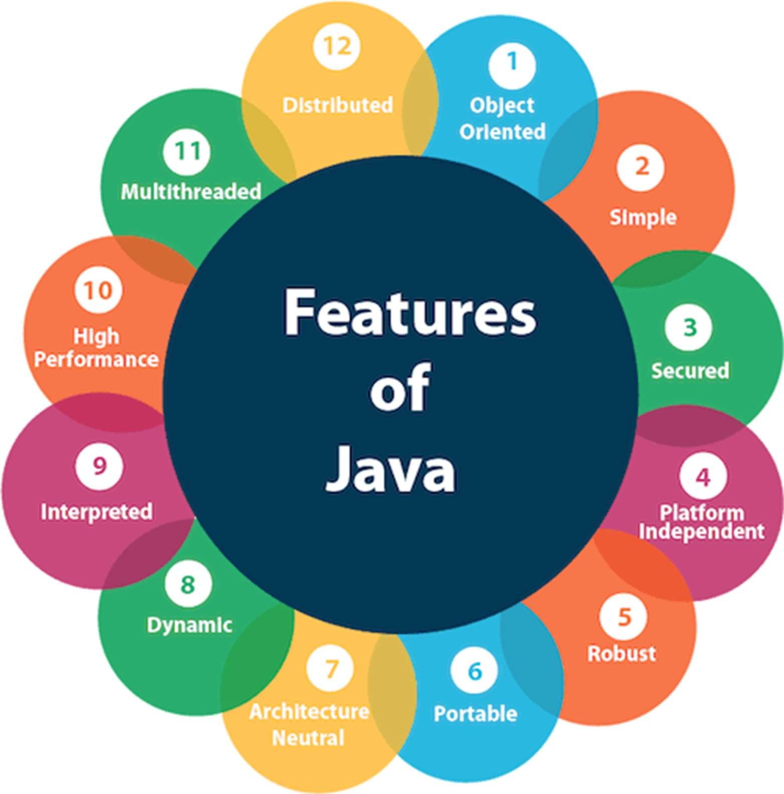

(Fig. 2.1 Features of JAVA)

1. Simple
2. Object-Oriented
3. Portable
4. Platform independent
5. Secured
6. Robust
7. Architecture neutral
8. Interpreted
9. High Performance
10. Multithreaded
11. Distributed
12. Dynamic

## Hardware Specification:

|  |  |
| --- | --- |
| **3.3.1** | Core i3 Processors. |
| **3.3.2** | 2 5 6 M B o f R A M. |
| **3.3.3** | Minimum 4G.B. Hard Disk. |
| **3.3.4** | Color/Black and White and Laser/ Ink Jet/ Dot Matrix printer. |
| **3.3.5** | 124 MB for JRE and 2 MB for Java Update DISK SPACE. |

*Table 2.1 (Hardware Specifications)*

## Software Specification:

|  |  |
| --- | --- |
| **3.4.1** | Operating System. |
| **3.4.2** | IntelliJ IDEA Community as Editor. |

*Table 2.2 (Software Specifications)*

## Feasibility Study:

In software development life cycle, it is a process that determines whether the solution under analysis is achievable, given the organization's resources and constraints. The feasibility study is the important step in any software development process. This is because it makes analysis of different aspects like cost required for developing and executing the system, the time required for each phase of the system and so on. If these important factors are not analyzed, then definitely it would have impact on the organization and the development and the system would be a total failure. So, for running the project and the organization successfully this step is a very important step in a software development life cycle process. In the software development life cycle after making an analysis in the system requirement the next step is to make analysis of the software requirement. In other words, feasibility study is also called as software requirement analysis. In this phase development team has to make communication with customers and make analysis of their requirement and analyze the system.

The feasibility study is a major factor which contributes to the analysis and development of the system. The decision of the system analyst whether to design a particular system or not depends on its feasibility study. Study of requirement analysis is done through different feasibility study. Feasibility study is undertaken whenever a possibility of probability of improving the existing system or designing new system. Feasibility study helps to meet user requirements. It enables

us to determine the potential of existing system and improving it. It helps to develop a technically and economically feasible system. It helps to know what should be embedded in the new system. It also helps to develop a cost-effective system. We can make better utilization of available resources.

## Advantages of Making Feasibility Study:

There are many advantages of making feasibility study some of which are summarized below: This study being made as the initial step of software development life cycle has all the analysis part in it which helps in analyzing the system requirements completely. Helps in identifying the risk factors involved in developing and deploying the system. The feasibility study helps in planning for risk analysis. Feasibility study helps in making cost/benefit analysis which helps the organization and system to run efficiently. Feasibility study helps in making plans for training developers for implementing system. So, a feasibility study is a report which could be used by the senior or top persons in the organization. This is because based on the report the organization decides about cost estimation, funding and other important decisions which is very essential for an organization to run profitably and for the system to run stable.

## Type of Feasibility Study

The project concept is feasible because there are many different types of feasibility studies; here is a list of some of the most common.

* + - 1. **Technical Feasibility: -** Technical feasibility it is the study of hardware and software requirement on which the application is to be used upon. It is important to consider the budget of the system or the overall cost. The proposed system is technically feasible as it can be developed easily with the help of available technology. No expert man power is required for this purpose. Does the company have the technological resources to undertake the project? Are the processes and procedures conducive to project success?
      2. **Schedule Feasibility: -** A project will fail if it takes too long to be completed before it is useful. Typically, this means estimating how long the system will take to develop, and if it can be completed in a given time period or not. Given our technical expertise, are the project deadlines reasonable? Some projects are initiated with specific deadlines. It is necessary to determine whether the deadlines are mandatory or desirable. Does the company currently have the time resources to undertake the project? Is the project compliable in the available time?
      3. **Economic Feasibility: -** This area is concerned with cost for the development and implementation of the system. It also includes the maintenance of the system post development. So the actual cost of the system is important before designing a new system. The usage time period has to be determined so that the company can analyze whether this system will prove beneficial to the organization or not. All this is studied in economic feasibility study. The economic feasibility study is more commonly called the cost/benefit analysis.
      4. **Cultural Feasibility: -** What will the impact on both local and general cultures be? What sort of environmental implications does the feasibility study have?
      5. **Legal/Ethical Feasibility: -** It includes the study that the current software doesn’t get the developers or the educational institutes in legal problems under copyright acts or others. Utmost care has been taken that the current software is free from all such legal troubles and the source code is not copied from anyone. We have made sure that the project undertaken will meet all legal and ethical requirements before the project is on the table. What are the legal implications of the project? What sort of ethical considerations are there?
      6. **Resource Feasibility: -** It includes the study of whether the educational institutes have the technological resources to undertake the project? Are the processes and procedures conducive to project success? If not, then what will be the effects on the cost for the software? Do you have enough resources, what resources will be required, what facilities will be required for the project, etc.?
      7. **Operational Feasibility: -** Automation makes lives easy. The proposed system is very user friendly and the user is much easily able to interact with the system. Therefore, the users will readily accept the system as data entry and making queries can be easily done. This measure how well your company will be able to solve problems and take advantage of opportunities that are presented during the course of the project.

## Fact Finding Techniques:

Analysis of the new system is very important to conduct before making the actual product. It is important to collect the facts and relevant information to make a useful and efficient product and to minimize the risk factor. The data collected in the fact finding technique are examined to determine how well the system will be performing. The specific methods for finding information of the system are termed as fact finding techniques. The analyst may use more than one technique for investigation.

### Following are the fact finding techniques: -

1. **OBSERVATION: -** Observation technique involves the view of processes involved in the stationery department of the educational institutes and noticing the minute details of their procedures to develop the application with accurate information.
2. **FIELD VISITS**: **-** This project required lots of field visits. I visited not only the stationery department but also to the library department and accounts section to get a view of how the things are coordinated with the accounts section specifically to accept the bills and maintenance.
3. **INTERVIEW: -** Interviews are an integral part of any research. It is important to interview the relate authorities in order to get raw data and transform it into information accurately. I collected information from the stationery department of the educational institutes. I gathered information about the suppliers that provide materials to the educational institutes.

# PRODUCT TABLE

|  |  |  |
| --- | --- | --- |
| **PRODUCTS** | **TYPE** | **COMPANY** |
| **PEN** | GEL | NATRAJ |
| CELLO |
| LINC |
| TRIMAX |
| WRITOMETER |
| BUTTER_FLOW |
| BALL | PARKER |
| MAXWRITER |
| BOB |
| INK | |
| **PENCIL** | | NATRAJ |
| DOMS |
| EXTRADARK |
| **ERASER** | | MIN |
| DOS |
| CLASSMATE |
| **SHARPENER** | | NAT |
| SHARP |
| ALOB |
| **SCALE** | | MEASURE |
| SOS |
| BAR |
| **PROTECTOR** | | FINS |
| ANGLE |
| DARK |
| **COMPASS** | | COMP |
| NIB |
| STROKE |
| **DIVIDER** | | SATA |
| NATA |
| KATA |

|  |  |  |
| --- | --- | --- |
| **PRODUCTS** | **TYPE** | **COMPANY** |
| **NOTEBOOKS** | ROUGH-NOTEBOOK |  |
| FAIR-NOTEBOOK |
| **BOOKS** | C++ |  |
| DATAWARE HOUSE |
| CLOUD COMPUTING |
| OPERATING SYSTEM |
| INFORMATION SECURITY |
| ALGORITHMS BY CORMEN |
| JAVA |
| DATA STRUCTURE |
| COMPILER DESIGN |
| COMPUTER NETWORK |
| COMPUTER ARCHITECTURE |

*Table 2.3 (Product Table)*

# CHAPTER-3

**OUTPUT**

## 3.1 OUTPUT SNAPSHOTS:

**HOME PAGE**

The Home page is loads when the Program starts. The term is also used to refer the front page, or main page of a group, company, organization, or individual.

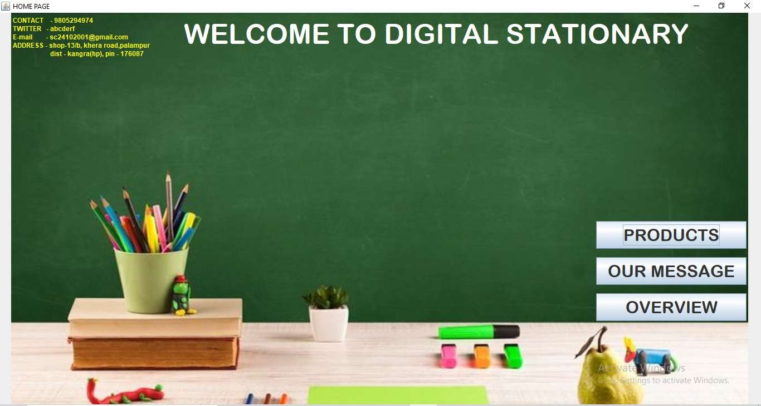

## PRODUCT PAGE

(Fig. 3.1 Home)

The Product Page is loads when the PRODUCT button is press. This show the products.

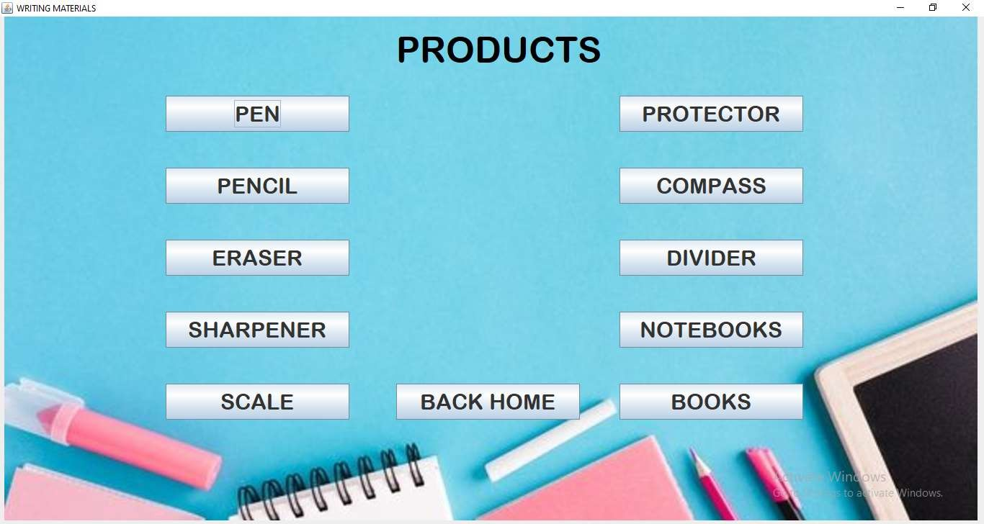

(Fig. 3.2 Product)

## TYPE OF PEN PAGE

The Type of Pen Page is loads when the PEN button is press. This show the type of pens.

## GEL PEN PAGE

(Fig. 3.3 Pen)

The Gel Pen Company page is loads when the GEL-PEN button is press. This show the type of Gel-Pens.

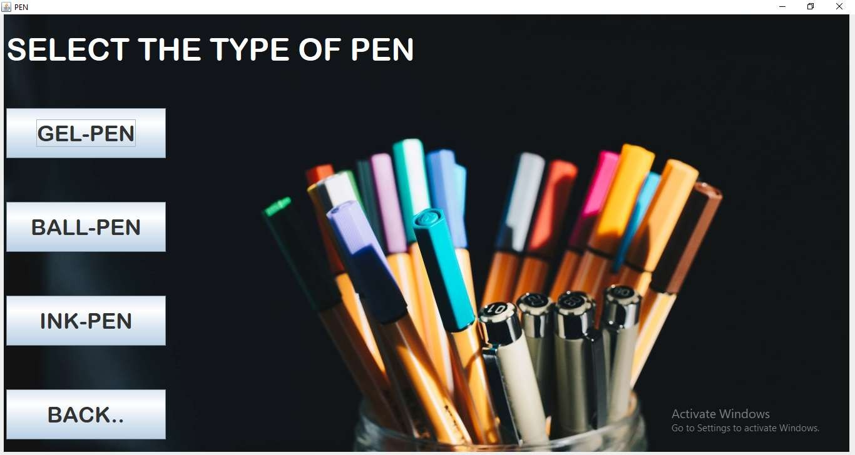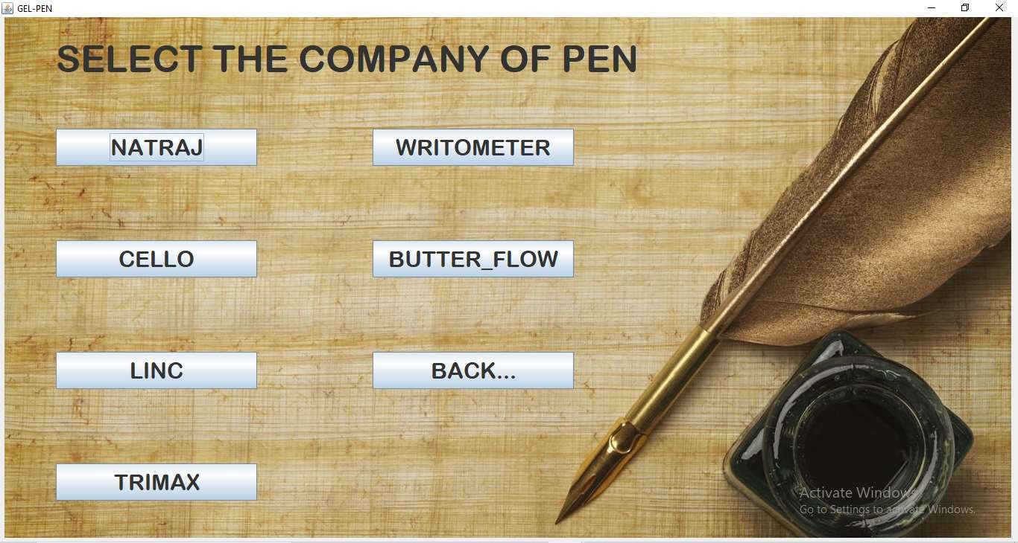

(Fig. 3.4 Gel Pen)

## BALL-PEN PAGE

The Ball Pen Company page is loads when the BALL-PEN button is press. This show the type of Ball-Pens.

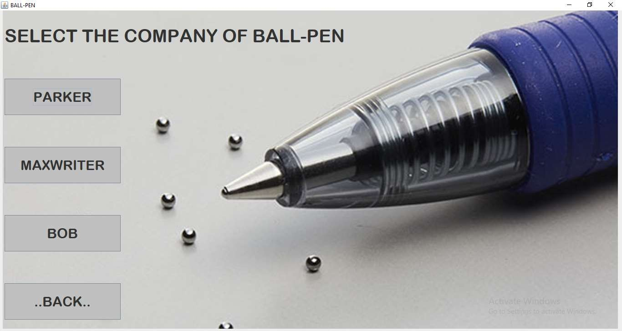

## PENCIL PAGE

(Fig. 3.5 Ball Pen)

The Pencil Company page is loads when the PENCIL button is press. This show the type of Pencils.

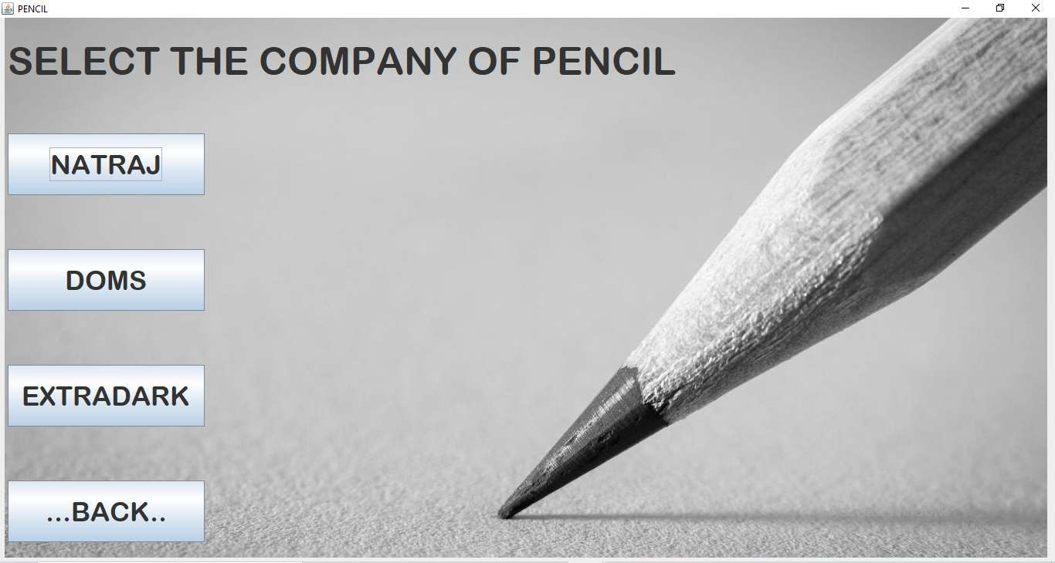

(Fig. 3.6 Pencil)

## ERASER PAGE

The Eraser Company page is loads when the ERASER button is press. This show the type of Erasers.

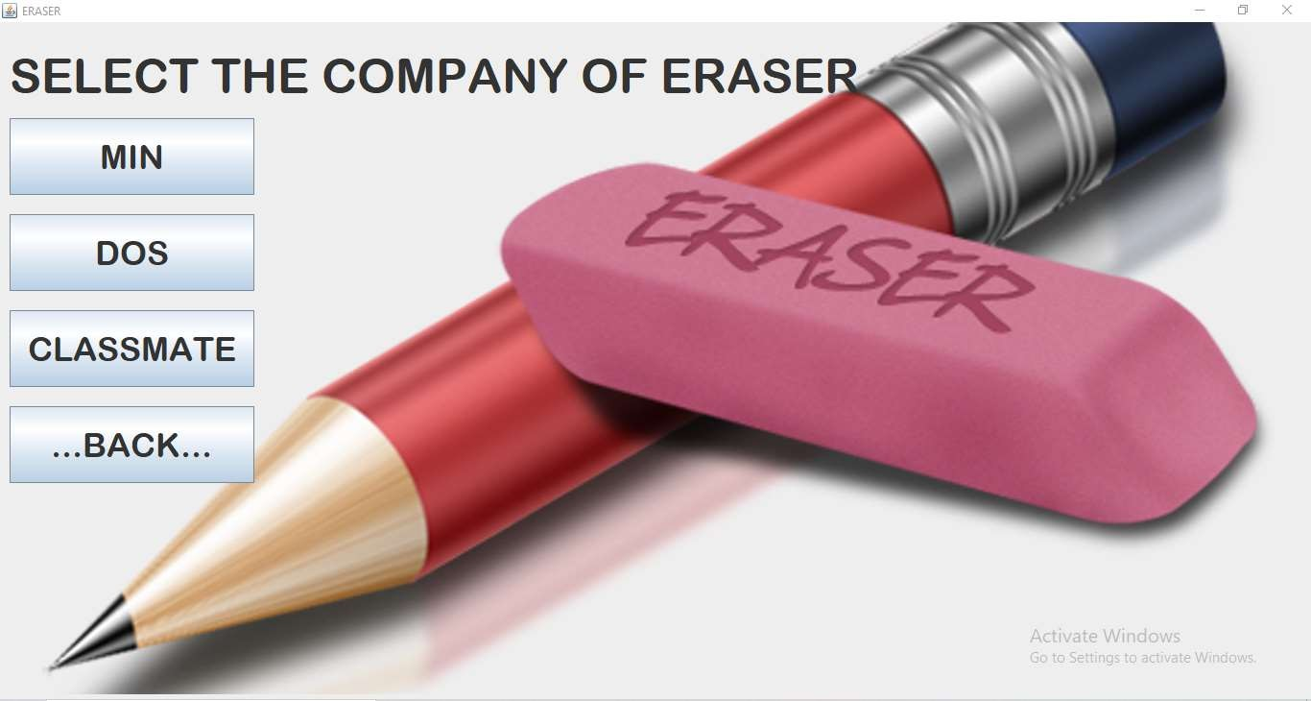

## SHARPENER PAGE

(Fig. 3.7 Eraser)

The Sharpener Company page is loads when the SHARPENER button is press. This show the type of Sharpeners.

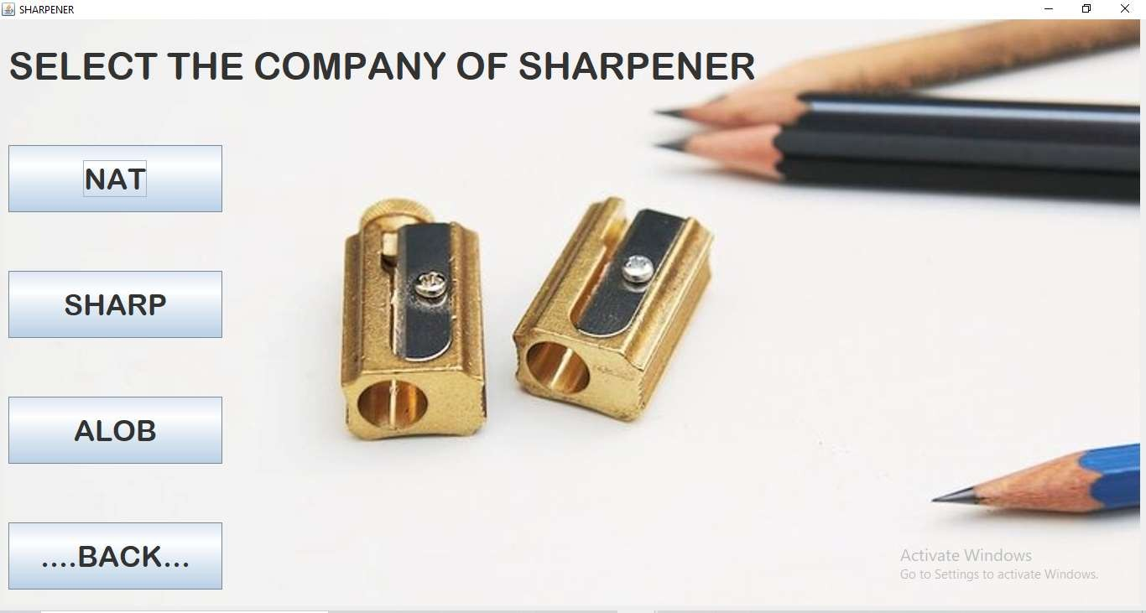

(Fig. 3.8 Sharpener)

## SCALE PAGE

The Scale Company page is loads when the SCALE button is press. This show the type of Scale.

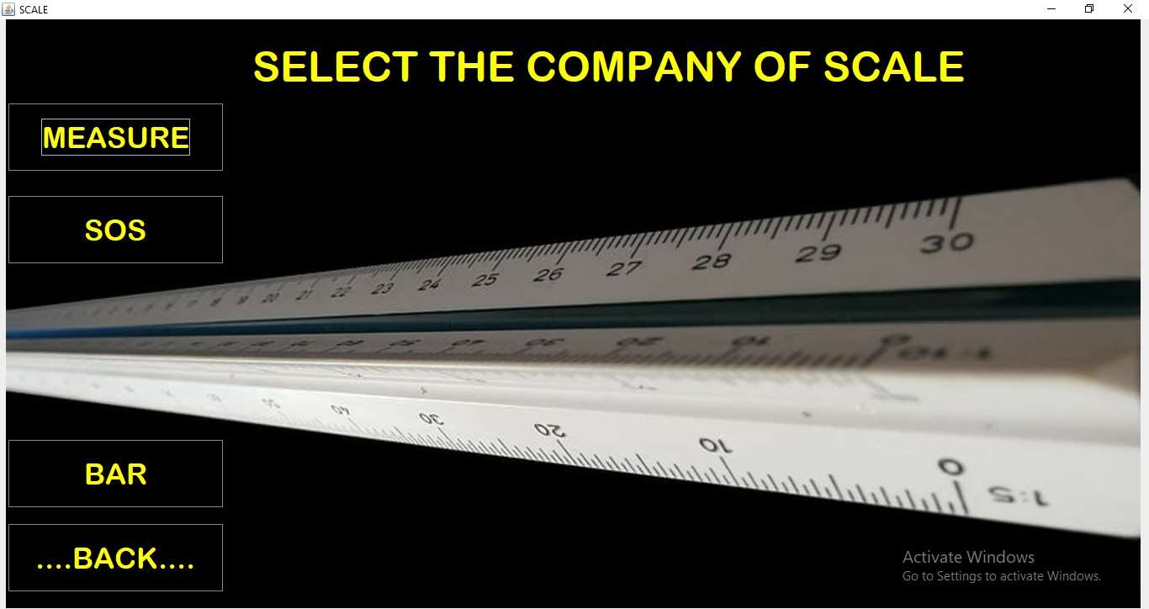

## PROTECTOR PAGE

(Fig. 3.9 Scale)

The Protector Company page is loads when the PROTECTOR button is press. This show the type of Protector.

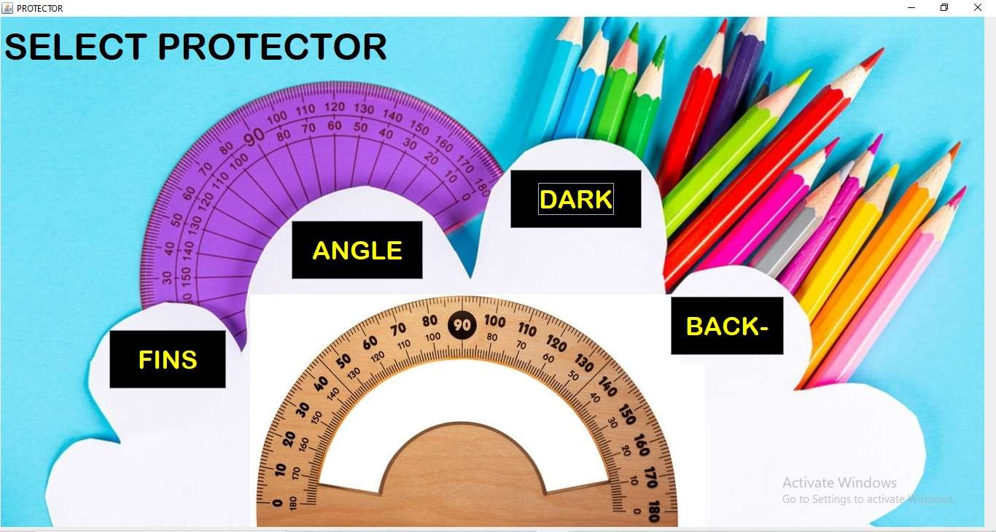

(Fig. 3.10 Protector)

## COMPASS PAGE

The Compass Company page is loads when the COMPASS button is press. This show the type of Compass.

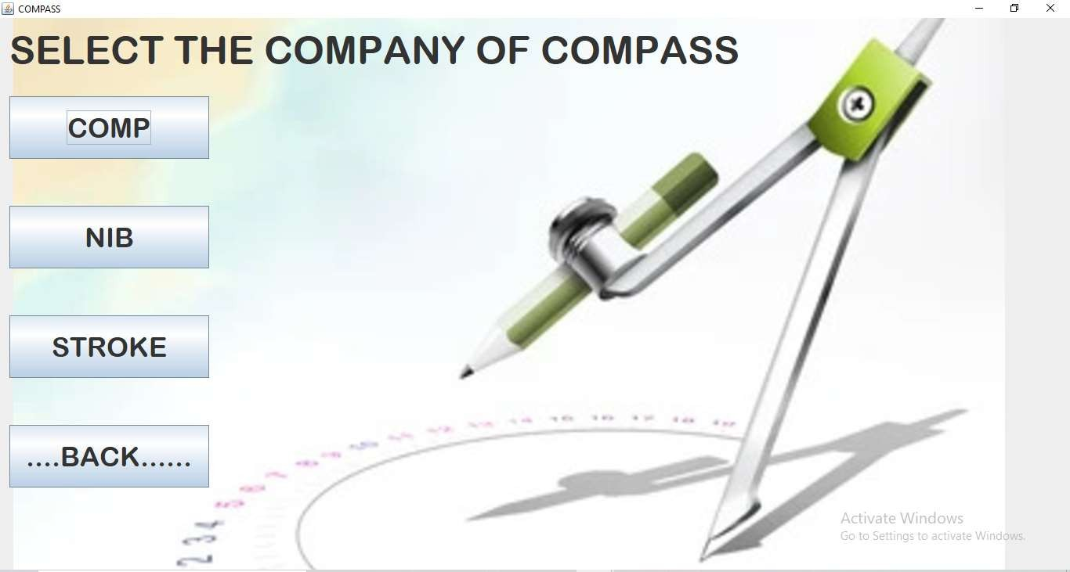

## DIVIDER PAGE

(Fig. 3.11 Compass)

The Divider Company page is loads when the DIVIDER button is press. This show the type of DIVIDER.

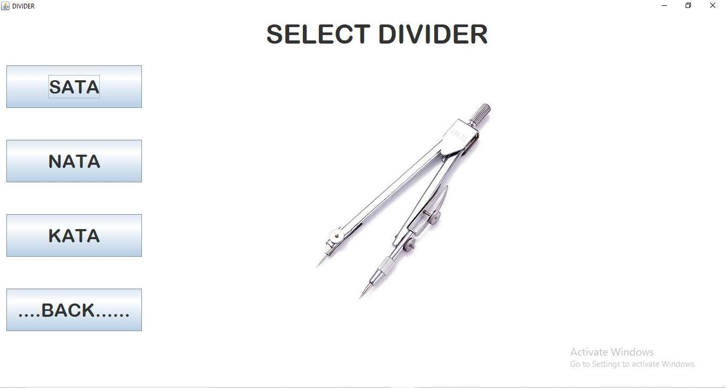

(Fig. 3.12 Divider)

## NOTEBOOKS PAGE

The Notebooks Company page is loads when the NOTEBOOK button is press. This show the type of Notebooks.

## BOOKS PAGE

(Fig. 3.13 Notebooks)

The type of Books page is loads when the BOOKS button is press. This show the type of Books.

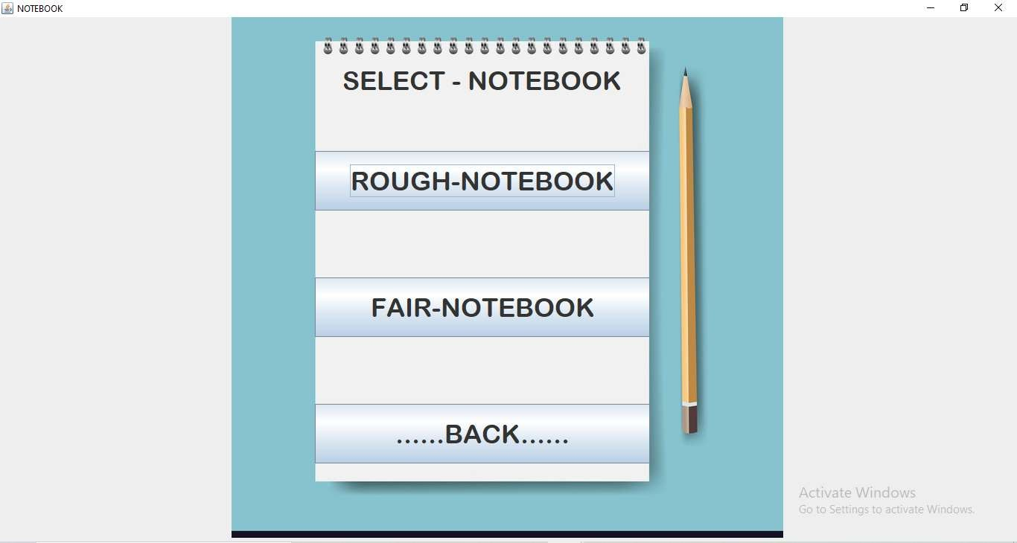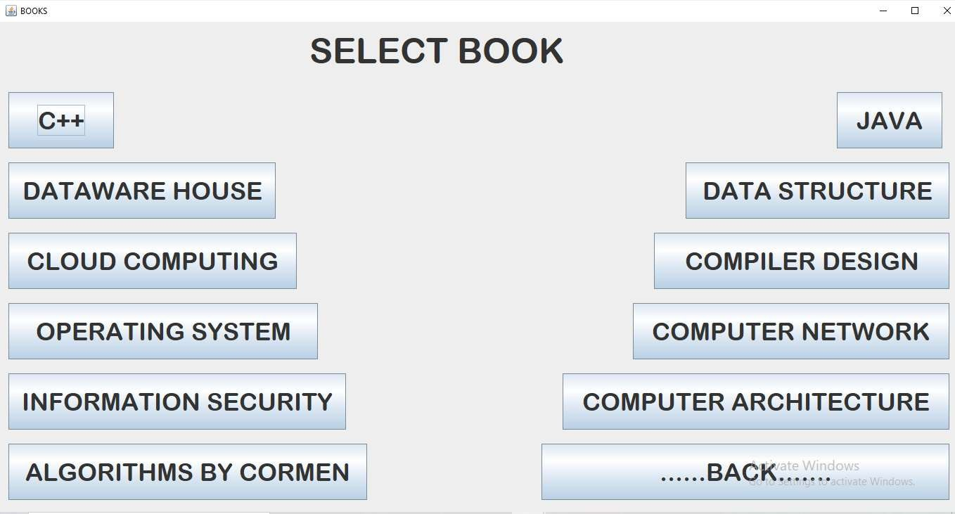

(Fig. 3.14 Books)

## ORDER PAGE

The Order page is loads when the type of product button is press. This show the order section.

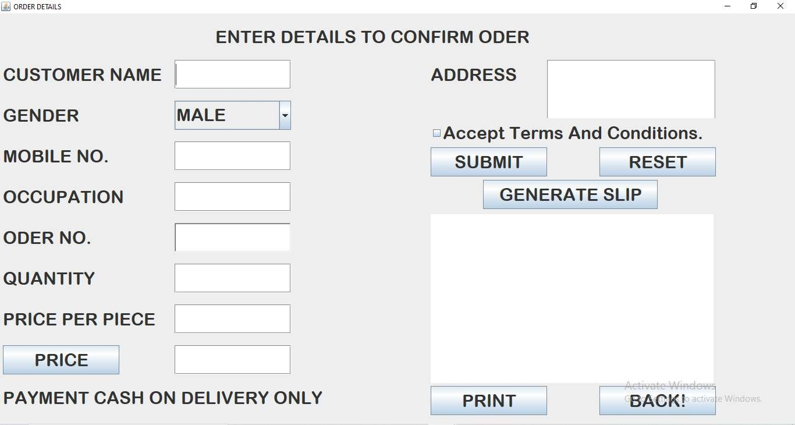

(Fig. 3.15 Order)

## ORDER CONFIRM

The Confirm Dialog Box is loads when the SUBMIT button is press. This show placed successfully.

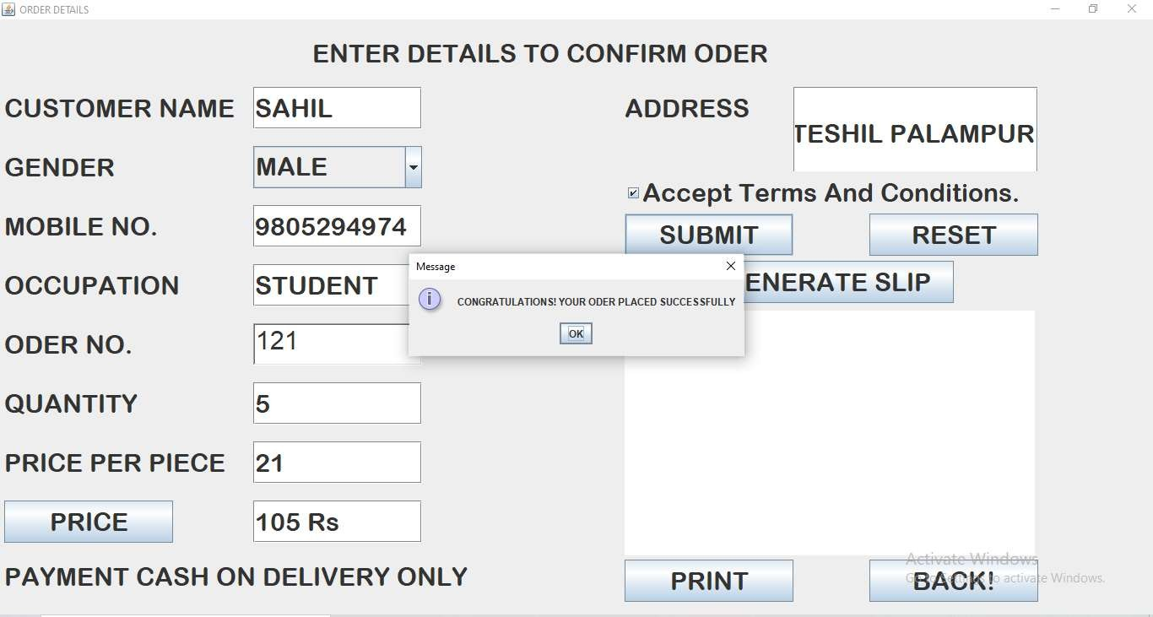

(Fig. 3.16 Oder Confirm)

## BILL PAGE

The Bill page is loads when the GENERATE SLIP button is press. This show the entered details.

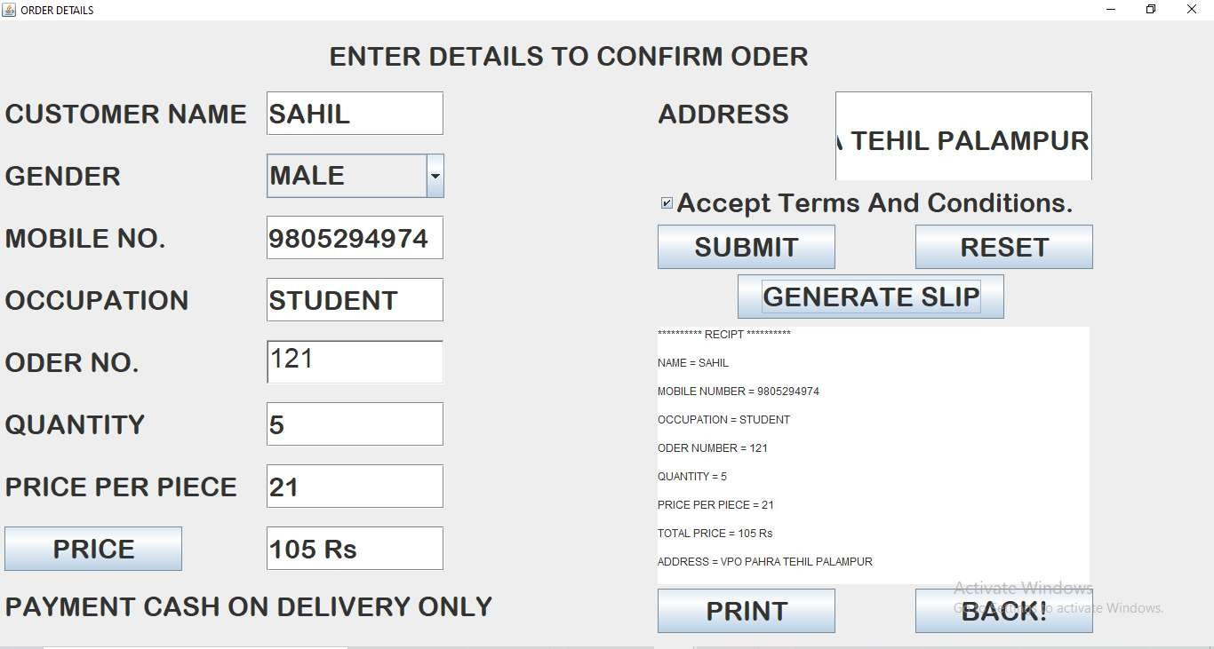

(Fig. 3.17 Bill)

## PRINT BILL PAGE

The Print page is loads when the PRINT button is press. This show the printing process.

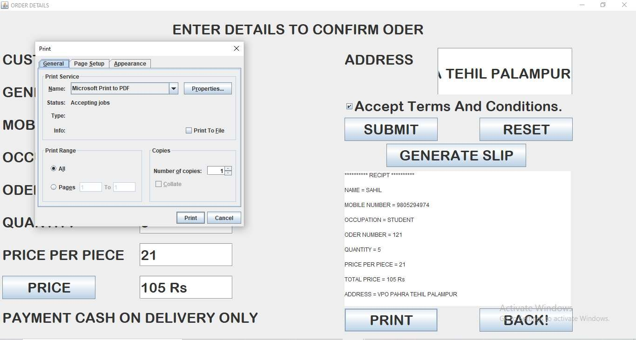

(Fig. 3.18 Bill Print)

## AFTER PRINT

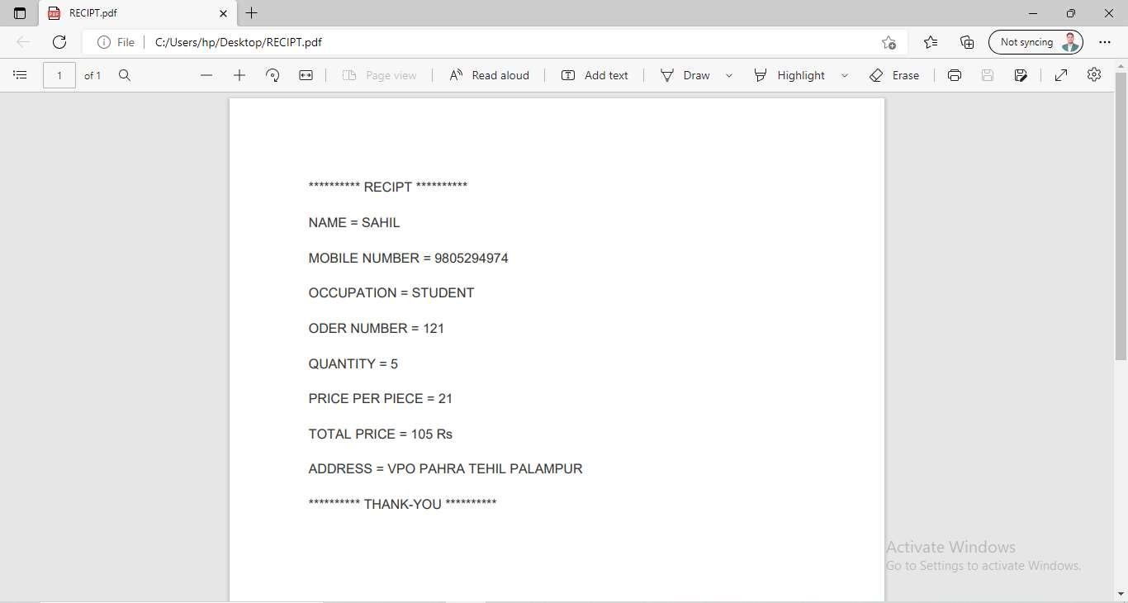

The slip is save as PDF if printer is not connected.

(Fig. 3.19 Receipt)

# CHAPTER-4

**CONCLUSION**

## 4.1 Conclusion

Time and money are one of the most important factors to any organization. Implementing such a software in the educational institutes stationery department can surely be a profitable deal as this application helps to carry out tasks with ease and thereby reduces time and money on manpower and materials. This is an open source application so that others can edit and transform this system application according to their needs.

## Advantages

The system is very simple in design and to implement. The system requires very low system resources and will work in almost all configurations.

### It has got following advantages:

* + - User friendly application
    - Open source application
    - Simple coding techniques
    - Easy maintenance
    - Fast processing and handy
    - Data can be updated easily
    - System reduces manual workload
    - Less error prone and accuracy is maintained
    - Provides reports of data

## Limitations

* + - It can’t be connected to the internet
    - Initially, it may seem to be a costly investment but eventually it is profitable as it saves money on manpower, materials, etc.

# APPENDIX

## APPENDIX 1

The tools and technology in the development of the system are:

## JAVA

Java is a programming language and a platform. Java is a high level, robust, object-oriented and secure programming language. Java was developed by *Sun Microsystems* (which is now the subsidiary of Oracle) in the year 1995. *James Gosling* is known as the father of Java. Before Java, its name was *Oak*. Since Oak was already a registered company, so James Gosling and his team changed the name from Oak to Java.

The principles for creating Java programming were "Simple, Robust, Portable, Platform- independent, Secured, High Performance, Multithreaded, Architecture Neutral, Object- Oriented, Interpreted, and Dynamic".

Java was developed by James Gosling, who is known as the father of Java, in 1995. James Gosling and his team members started the project in the early '90s. **James Gosling, Mike Sheridan**, and **Patrick** initiated the Java language project in June 1991. The small team of sun engineers called **Green Team**.

Currently, Java is used in internet programming, mobile devices, games, e-business solutions, etc. Following are given significant points that describe the history of Java.

**IntelliJ IDEA**

IntelliJ is one of the most powerful and popular Integrated Development Environments (IDE) for Java. It is developed and maintained by **Jet Brains** and available as community and ultimate edition. This feature rich IDE enables rapid development and helps in improving code quality.

IDE stands for Integrated Development Environment. It is a combination of multiple tools, which make software development process easier, robust and less error-prone.

### It has following benefits over plain text editor –

* + - Integration with useful tools like compiler, debugger, version control system, build tools, various frameworks, application profilers and so on.
    - Supports code navigation, code completion, code refactoring and code generation features which boosts development process.
    - Supports unit testing, integration testing and code coverage via plug-ins.
    - Provides rich set of plug-ins to enhance **IDE** functionality further.

# REFERENCES

**BOOK REFERRED**

* Scheldt Herbert, ―Java: The Complete Reference‖, Tata McGraw-Hill.
* E Balagurusamy, ―Programming with java A Primer Fourth Edition‖.
* Rao Nageswara, ―Core Java: An Integrated Approach‖, Dreamtech Press

## WEBSITES REFERRED

* [www.javatpoint.com](http://www.javatpoint.com/)
* [www.geeksforgeeks.com](http://www.geeksforgeeks.com/)
* [www.studytonight.com](http://www.studytonight.com/)
* [www.w3school.com](http://www.w3school.com/)
* [www.tutorialpoints.com](http://www.tutorialpoints.com/)
* [www.youtube.com](http://www.youtube.com/)

# APPROVAL SHEET

This Industrial Training Report entitled **(STATIONERY MANAGEMENT SYSTEM)** by **SAHIL** with University Reg. No **1913031026** senior student of *HIMALAYAN INSTITUTE OF ENGINEERING AND TECHNOLOGY, KALA-AMB (H.P.)* is approved for the degree of **B.Tech** *(COMPUTER SCIENCE ENGINEERING).*

**SUPERVISOR**

**HEAD OF DEPARTMENT**